**LAB - 2**

**Amit Kumar Sahu**

**18MIS7250**

**SAQ 1**

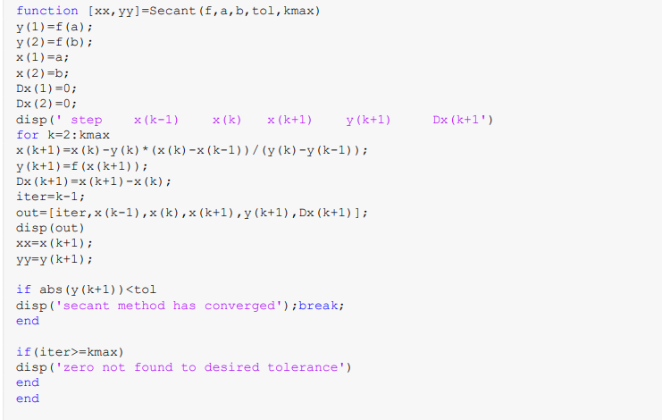

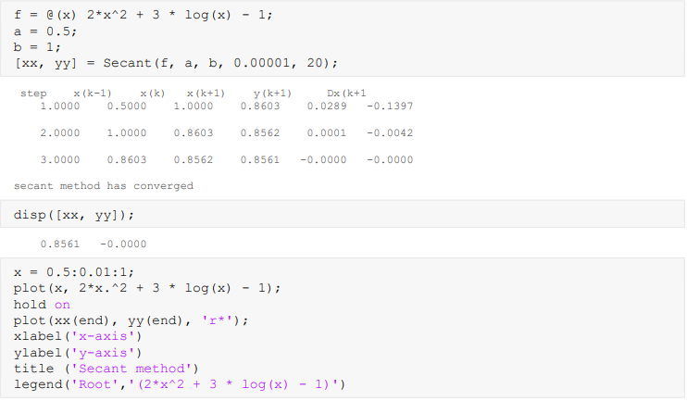

OUTPUT:

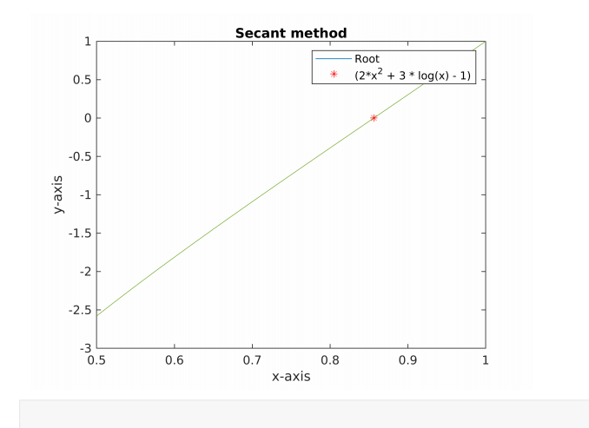

For the problem given keeping values and solving:

